Reproductive Health and Relationships Education

Secondary School Package
These guides are designed to help teachers provide comprehensive reproductive health and relationships education, free from myths, to young people so they will better understand their changing bodies and emotions. The sessions will ideally be divided into a number of educational encounters, to be presented over time. At the beginning of any session, it is important for the teacher to discuss class rules including concepts such as mutual respect between students and consideration of the feelings of fellow students. The teacher should also make children aware that some students may have had experiences they don’t fully understand, so all participants should be allowed to speak without judgement.
Some teachers may feel uncomfortable teaching certain details of reproductive health or they may find some of the information is not in agreement their own views such as contraception, for example. In these situations it is important for the teacher to be aware of their own personal views and not let their views influence the teaching of the basic health information presented in this document. Each child deserves objective information about their bodies and relationships in order to prepare them for the decisions they will need to make in their lives. Research has conclusively found that providing comprehensive reproductive health and relationship information to children and young people has 3 very important benefits: 1) it reduces the likelihood of unwanted or underage pregnancies, 2) it reduces the rates of sexually transmitted diseases, 3) and it makes young people more likely to delay initiation of sexual activity until an older age.

Objectives
- Educate young people about healthy relationships.
- Allow young people to ask questions about their bodies, their experiences, and sex in general.
- Educate young people about consent (permission).
- Empower young people to say no to unwanted sex.
- Empower young people to make good choices and be respectful of themselves and others.
- Reduce the risk of sexual assault in young people.
- Empower young people to take control of their own sexual health, including contraception.
- Inform young people about where to seek help if necessary.

Evidence for sexuality education:
- Sexuality education has been shown to reduce adolescent sexual activity, sexual risk-taking behaviour and rates of STDs or HIV.
- Sexuality education increases people’s knowledge and improves their attitudes about sexual and reproductive health and behaviours.
- Abstinence-only education has been found to be INEFFECTIVE in delaying sexual initiation, reducing frequency of sex or reducing the number of sexual partners.
- Sexuality education is most effective when school-based programs are combined with community activities such as condom distribution, involvement of parents, and health provider training to deliver youth-friendly services.

How this Package is designed:
The following package contains a collection of topics that should be covered within a child’s school life. Some aspects will have already been covered within other subjects, such as biology.
Many of the topics have suggestions of activities that can be used to make the program interactive for the children. This will help them retain the information, as well as develop interaction skills and independence. Some activities are indicated as more suitable for older children and some are indicated as suitable for younger children.
Each topic has specific Teacher Reference Sheets that contain information for the teacher or counsellor. The information within these sheets is often more in-depth than the children will need to know, but it may help the teacher when answering questions or planning lessons. It is advised that the teacher or counsellor read these Reference Sheets before presenting the lesson/session.
The written package is supported by videos produced by Empower Tanzania. These provide information in visual form through animation and film and can be shown within the sessions as appropriate, but should be accompanied by teaching and discussion.
This is specially designed for secondary schools. There is a similar package for primary schools that will include the much of the same content, but less information about STDs, contraception and sexual intercourse.

Student learning builds on the knowledge that the student already possesses and is more than just receiving and processing information transmitted by teachers. Student learn best when they build their understanding by discussion with personal opinions and experiences. Giving students the opportunity to think about their own lives enhances the learning of information received from teachers.

Relationships
The goal of the relationships portion of this guide is to teach children that a healthy relationship is:
- Consensual and non-exploitative
- Concerned about consequences such as sexually transmitted diseases (STDs) and pregnancy
- Respectful and caring

All ages:
- Discuss what a relationship is.
This discussion should be broad, and include discussion of different types of relationships such as the child’s relationships with parents, friends, and people in town. Pupils should be encouraged to discuss what qualifies a ‘relationship’ and how they feel about themselves when they are with different people. E.g. happy, safe, loved etc.
- have children make a list of people they feel safe with in their lives, making this as personal as possible. For example, my mother, my teacher Mrs. Nzota, my Aunt Rehema. Get each child to write the names of these people down on a piece of paper, and decorate the paper, making it special to them.
These should not include generalizations, such as teachers, police etc. Try to encourage the children to choose a least one adult in school, and one from outside of school, so they have trusted adults identified as a contact for different parts of their daily lives. The children should be encouraged to keep this list somewhere safe, and to choose someone from this list if they ever feel they need to speak to someone.
It may be appropriate to explore and ensure the emotional qualities of the relationships the child writes down to ensure the child is identifying healthy relationships and not just ones that they believe are safe/trusting for possible manipulative/traumatic/guilt/shame reasons: “I trust Uncle Joseph because he tells me we can keep secrets with each other”.

Older children, ages 11+:
- Discuss “healthy” or “good” relationships.
Ask pupils how they will know if they are having a” good” or healthy relationship. This could include asking how they feel about themselves with that person (e.g. loved, important, safe) what they would do together to connect and have fun, or how disagreements or problems would be handled. Ask pupils to identify adults in their life who have a healthy relationship and what they see that tells them this.
- Discuss ‘unhealthy’ relationships.
Next discuss how pupils would tell if they have a ‘unhealthy relationship’. Emphasis should be put on identifying the emotions associated with harmful relationships (e.g. feeling uncomfortable around someone, feeling shamed or threatened, or feeling badly about self overall). Have pupils discuss ways they could identify if a relationship is moving in an unhealthy direction early on.
Have the young people identify as many behaviours or feelings as they can that may be associated with ‘unhealthy’ relationships. Examples are on the Teacher Reference Sheet.
- Discuss how someone would be able to tell if a friend is in a ‘unhealthy’ relationship
Examples can include the person being withdrawn or not spending much time with friends, misbehaving in school, being upset a lot of the time, etc.
- Discuss what steps a person should take if they, or a friend, are in an ‘unhealthy’ relationship.
Have the student refer to their ‘trusted people list’ they previously made for someone with which to discuss their “unhealthy” relationship. It is also good to speak about how someone should approach the subject with the person in the ‘unhealthy relationship’, ensuring they know not to be judgemental, or critical. They should approach the person with a supportive stance, and not force the other person to speak about it until they are ready. The student should know to speak to someone in an authoritative position if possible.
- Discuss romantic relationships.
Ask pupils how a person would know that they are attracted to someone. This could include feelings of excitement and happiness. Discuss examples of romantic relationships that are healthy and examples that are unhealthy.

Saying ‘No’.
At the end of every session, the teacher should ensure that all pupils understand they have the right to say no to anything they do not wish to happen within any relationships, romantic or otherwise. They should never feel forced into anything within a relationship. This includes being ‘pressured’ into doing anything sexual, such as having sex in payment for food, or having sex to keep the relationship. Try to be available for the children after the lesson if they want to talk.
Hearing ‘No’.
Respect of the opinions or others begins with listening to what they are saying. If someone is telling you no, this means “no”.
Teacher Reference Sheet

Relationships
Children learn about relationships from their own experiences. This includes experiences with parents, friends, siblings etc. If children are only subjected to unhealthy relationships, they grow to accept these as ‘healthy’. Unhealthy relationships can vary, from being disrespectful or uncaring, to being physically or emotionally abusive.
Signs of an unhealthy relationship in a person can be subtle. A young person may become more withdrawn in class, more nervous, act out in class by causing disruptions and getting into trouble when this was not a problem previously with that child. These behaviours may result from relationships in which the child is being humiliated, controlled or harmed, and they can be a cry for help.
An unhealthy relationship can cause a young person to become isolated from friends through a partner’s extreme jealousy. For example, the young person may not sit with their friends at lunch or avoid interacting in class as they normally would. Truancy is a sign that something in the young person’s life is not right – perhaps they are being stopped going to school by someone, being pressured to work instead of going to school, or pressured by a partner to spend more time with them. Teachers need to be aware of patterns in absences which may be a sign of child exploitation as severe as human trafficking or prostitution.
Having an adult they can trust may allow the young person to speak freely about their relationships and feel safe in doing so. There are some things that a teacher cannot help, such as a family’s financial struggles, but listening to the young person is important, as is providing them with a space to be themselves.

Here are a few examples of a ‘caring, healthy’ relationship that young people may identify:
Trust:  They can talk with you about worries or concerns. You know they won’t run off and tell their friends. You know they won’t share private things with friends or online. They trust you around different people. | Respect:  They make you feel good about yourself. They support you in difficult times. They encourage you to try new things. They include you in their life.
Feelings:  You have strong feelings for each other. You like each other for who you are. You feel relaxed and can have a laugh with them. | Responsibility:  You have both planned how you can keep safe. You will not do anything that will get the other into trouble.

Here are a few examples of ‘unhealthy’ relationships that young people may identify:
Controlling behaviour:  A controlling person may stop you from seeing your friends or going out, tell you what you can and cannot say, and never letting you be on your own. They may look at messages on your phone or social networking sites, take your money, threaten you or your friends or family, or try to isolate you from your friends and family. Controlling behaviours are often accompanied by emotional abuse (i.e. employing guilt, shame, or fear tactics). | Physical abuse:  Physical abuse includes hitting, pushing, scratching, punching, kicking, pulling hair, pushing or dragging you around. Threats of physical violence and throwing or breaking things are also forms of abuse.
Sexual abuse:  Any pressure on you to do something sexual you do not want to do is sexual abuse, whether it is through physical force, verbal abuse, threats, or even sexual insults. Forcing you to send sexual pictures of yourself via the internet on your phone or computer is also sexual abuse. Being exposed to pornography or nudity, or being made to witness sexual acts (including showing body parts without permission or engaging in masturbation in front of the young person) is sexual abuse. | Emotional abuse:  Emotional abuse includes insults, being made fun of, making you feel bad or worthless or putting you down in other ways. Being subject to unreasonable jealousy, lies, threats of personal injury to him/herself by the perpetrator if you leave a relationship, withholding of affection, and threats that no one will love, believe or help you if you try to leave the relationship, are examples of emotional abuse.

Healthy vs. Unhealthy Relationships Activity – For young people aged 14-16
The aim of this activity is to get young people to think about what they individually consider to be a ‘healthy relationship’. It will also help them understand that people’s ideas of relationships vary. The activity should increase the students’ self-awareness of their own understanding of relationships, enabling them to look at their own circumstances critically.
- Write ‘Healthy’ and ‘Unhealthy’ on the board.
- Break the class into small groups of pupils.
- Give each group a piece of paper that has a statement about a relationship on it and decide among their group whether this is healthy or unhealthy and stick it under that heading.
- When each group had placed their papers on the board, ask each group to explain why they chose to put that statement where they did. Then ask the class how this relationship could be made better.
The class should be encouraged to have a discussion. There should be no judgement or idea of ‘correct’ or ‘incorrect’ answers. The teacher should only act as a facilitator for the discussion. The teacher may ask prompting questions such as ‘how could this be made better?’

Statements for Healthy vs. Unhealthy Relationships Activity:
A boy notices his girlfriend is getting a lot of attention from two different boys at school. He goes up to each one separately and warns them to stay away from her ‘or else’.

A couple have been together for a month. The girl is texting other boys flirty messages and her partner does not know. She thinks that by not telling him, he will not get upset.
A boy walks his girlfriend to school every morning, meets her for lunch every day, and then picks her up to walk her home every afternoon.

A couple have an agreement that they will not put passwords on their phones and can check each other’s texts and emails whenever they feel like it.

One partner usually decides when, where and what they do together. The other partner says they do not like making decisions and does not mind.
A couple texts and messages each other all the time. But when they get together, whether alone or with friends, they feel uncomfortable talking to each other.
Partner one wants to have sex. Partner two says they are not ready, but after talking, gives in and has sex, even though they did not really want to.
A couple who is not married decides they both want to have sex. They agree that the girl should have the implant and the boy should wear condoms so they are both protected from risks.
A boy finds out he has an STD from a previous relationship. Since it is easily cured, he doesn’t tell his partner about it as he thinks that if she finds out she will break up with him. They continue having sex without using condoms.

A boy has a very strong religious background. He’s having sex with his girlfriend, but after each time he says he feels disgusting. His girlfriend tells him to ‘Get over it.’

A 16-year-old girl has a 26-year-old boyfriend. He has a job, a motorbike and a place to live where they can be alone. When they go out, he pays for everything.

Touch and Personal Space
It is important to discuss ‘good’ and ‘bad’ touch. Explain to children that touch can be good, bad or unwanted.
‘Good’ touch should make you feel positive e.g. hugs and kisses from family members or friends.

ACTIVITY. Aimed at 5+
- Make 3 columns on the board. Put a heading in each column including ‘Good’ ‘Unwanted’ and ‘Bad’.

- Ask the children to shout out ideas for touches that should make them feel good and positive. Write these on the board
Discuss different situations where touch is a positive interaction. Examples might be parents showing affection such as hugs, kisses and cuddles, someone holding your hand to keep you safe while you cross the road, or a doctor or nurse touching you if you are ill or hurt.

- Next ask children to shout out ideas of touches that may not feel good, but are necessary (‘good but unwanted touch’). Write these on the board under ‘unwanted’
Discuss why people may need to touch you in ways that don’t feel good. Examples include grabbing you to stop you running into the road, an examination by a doctor or nurse, or being forced to take medicine or injections. Here you can introduce the idea that a doctor or a nurse may need to see their ‘private areas’, but reinforce the doctor or nurse should ALWAYS explain why. In addition, the child should always be able to ask for a trusted adult or a same-gender healthcare provider to be present. Emphasize that children can say no, and should not be asked to keep any secrets from trusted adults.

- Finally ask the children to shout out examples of ‘bad’ touch.
This can include hitting, kicking, pinching, or touching a person’s ‘private area’ without medical or hygiene reasons. Again, reinforce that NO child should be asked to keep a secret from their trusted adults or from ANY adults. Manipulative adults may find a way to make the child feel good about the secret, but this doesn’t make it ok! If they are being asked to keep secrets, and don’t understand why, then they should talk to someone on their ‘trust list’. It may be helpful to discuss “acceptable secrets” with the children and identify which types of secrets are okay to keep (“Don’t tell Auntie we got her this gift today so that tomorrow it will be a surprise!”).

It is important to note that “getting permission” from a child is NOT consent because a child is not able to consent to touch in private areas. There is no reason they should ever be touched in private areas by an adult unless it’s for medical treatment or cleaning purposes .

See next page for example.
Example:
Good Touch
Hugs from family
Hugs from friends
Kisses from parents
High-Fives/Fist bumps
Holding hands
Carrying a sibling
Breast feeding

Unwanted Touch
Vaccinations
Being forced to take medicines
Mama grabbing me to stop me running into the road or a fire.
Washing an injury
Bathing a young child

Bad Touch
Hitting
Kicking
Pinching
Touching someone’s ‘private’ areas without medical or hygiene need

Negotiating and Saying ‘No
There are many reasons why saying ‘no’ may be difficult. Saying ‘no’ effectively is a useful skill not just for sexual situations, but for life in general. There will be times in every person’s life when they have been asked to do something, maybe at work, or by a friend, that they want to say “no” to.
- Discuss with the class: When have you said no? When have others said no to you? Do you feel you always have the choice to say no? Have you ever found it difficult to say no? In what circumstances was it difficult?

There are four elements to saying no effectively:
• Intention – to mean ‘no’
• Body language – for your body to be saying ‘no’
• Words – to say ‘no’ clearly
• Tone of voice – to sound like you mean ‘no’.

Activity – Negotiating in role play – All Ages
- Have the children identify a few scenarios where they really want to say no, for example a sibling wanting to borrow clothes, or a friend wanting to copy homework answers. Write these scenarios on a board. Split the children into groups.
- Give 2 groups the same scenario, such as copying homework answers.
- Group one will try to persuade the other group to allow them to copy the homework.
- The other group will resist and be the ones saying “no”.
- Have them argue for a while. When you feel there has been enough, have all the children sit down and identify the effective ways of saying “no” that they witnessed.
This may include, having eye contact, being clear when they spoke, good posture. Write these effective ways on the board. It is also good to draw attention to the different ways of saying “no” – firmly (needed in serious situations); nicely/politely (needed in everyday situations such as being in shops); and a negotiated/compromised “no” (needed in friendships, work and sometimes relationships).

Reproductive Anatomy
Next, it is important for children and young people to understand their bodies. Boys and girls should learn about their genitals and those of the opposite sex. The essential anatomical parts that all children must know are: the penis, testicles, vagina, uterus, ovaries, fallopian tubes and genitals.

Female Reproductive Anatomy
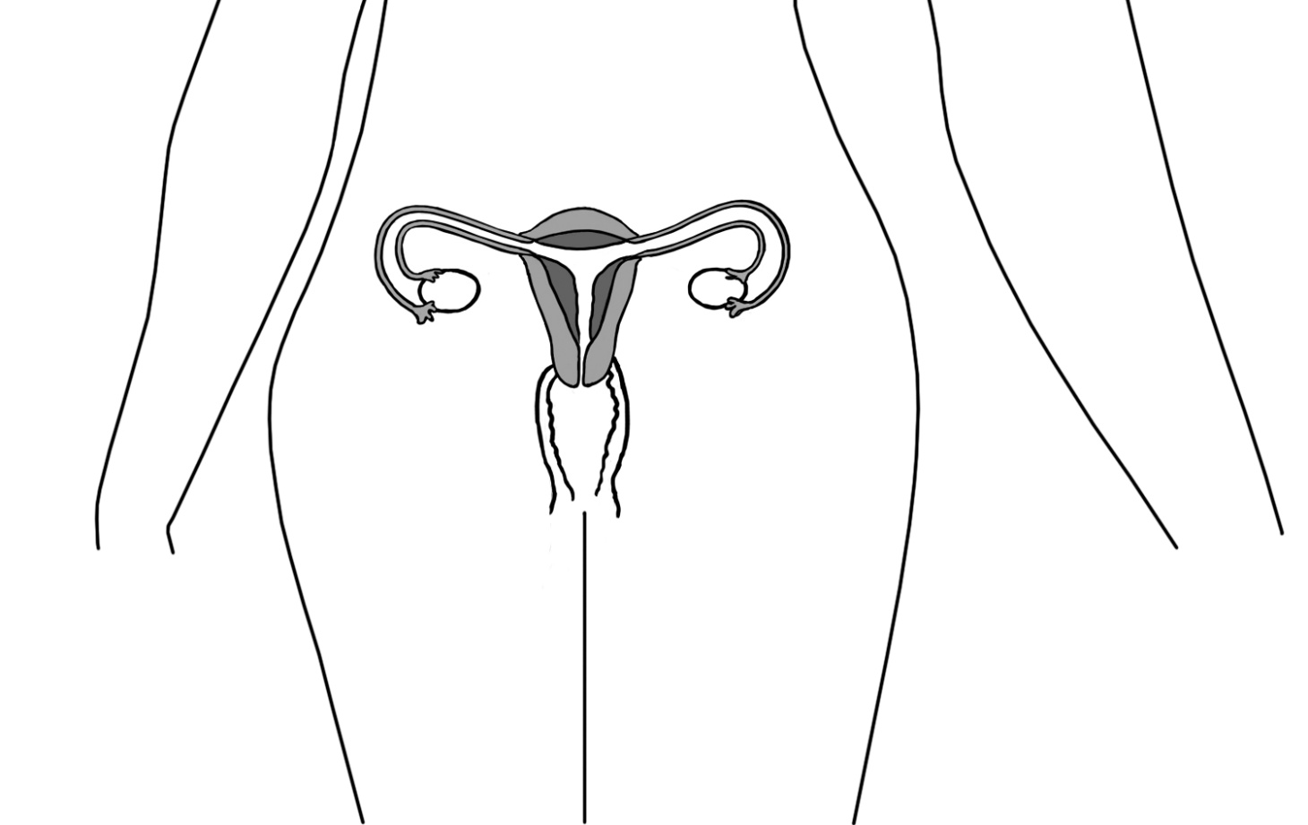
Fallopian tube
Fallopian tube
Ovary
Ovary
Vagina
Uterus
Cervix

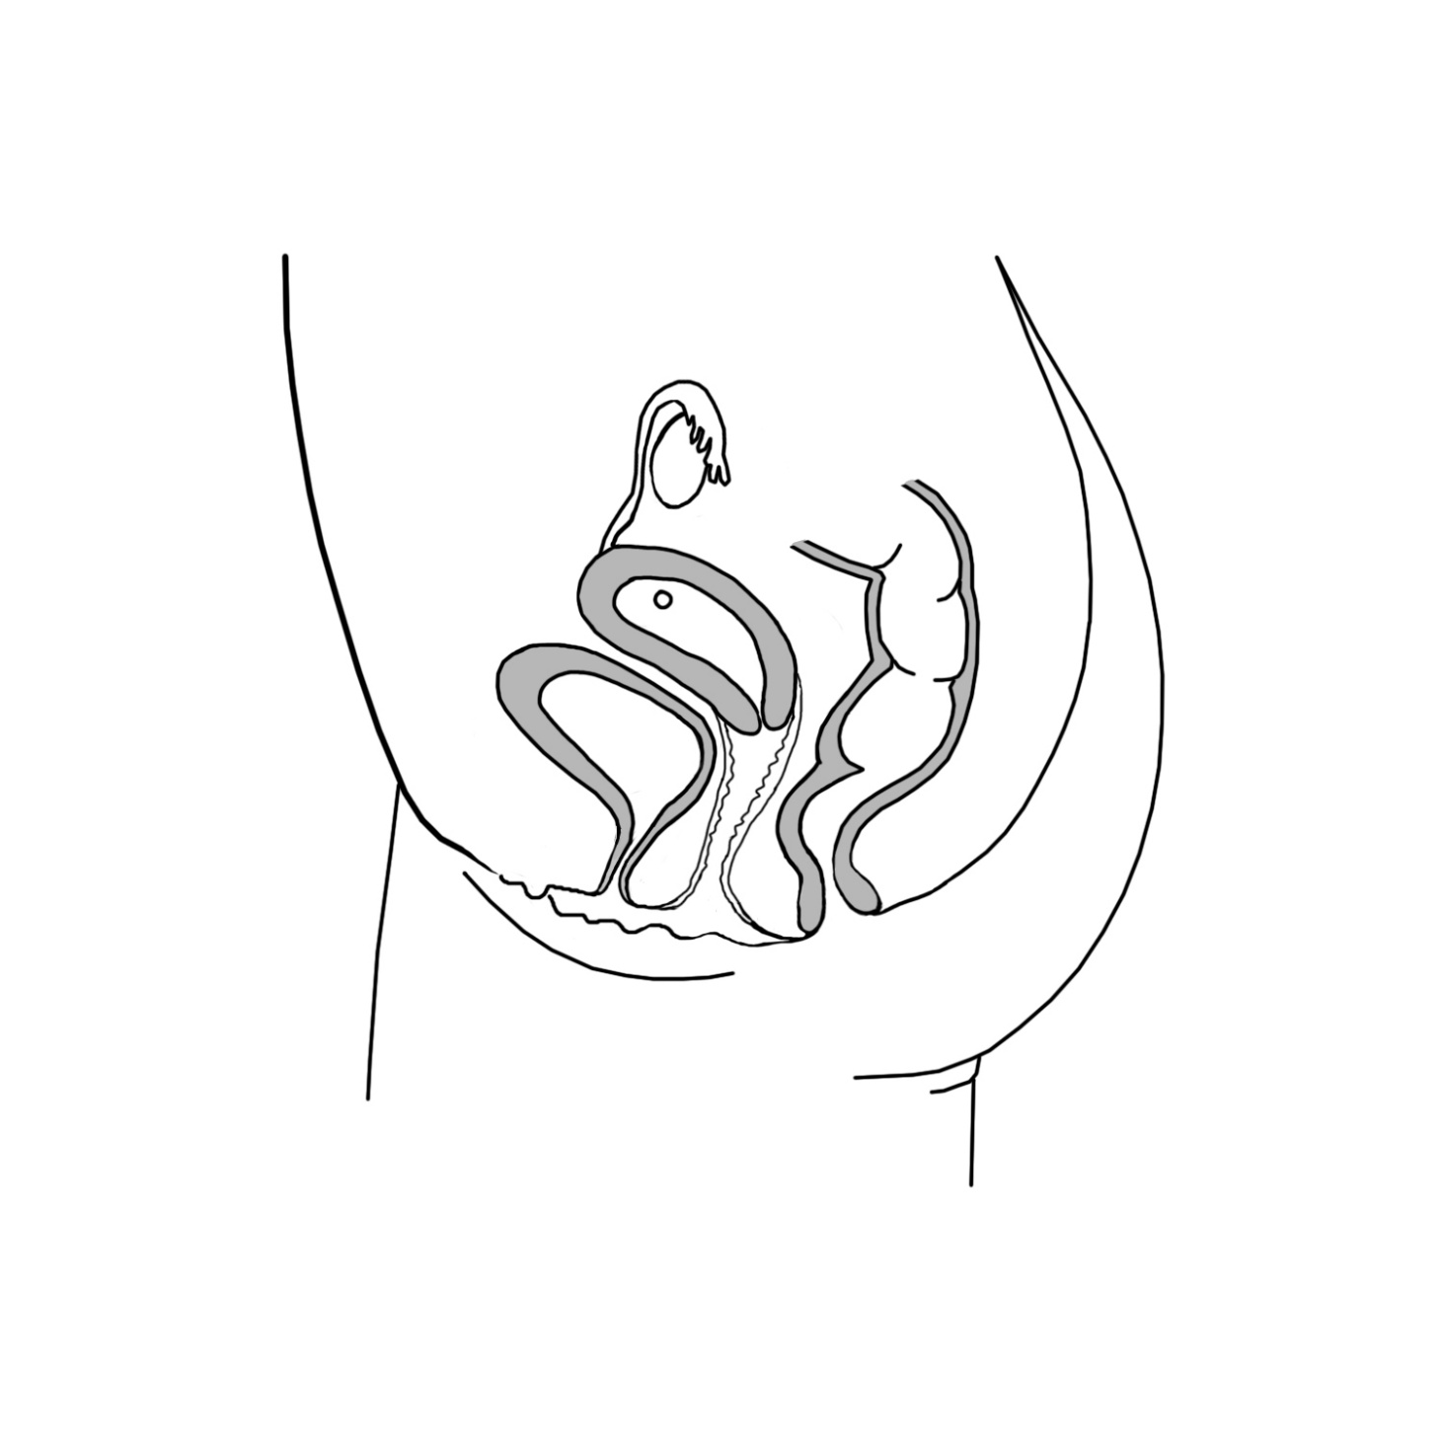
.
Bladder
Fallopian Tube
Ovary
Uterus
Cervix
Rectum
Anus
Vagina
Urethra
Labia
Clitoris

Reproductive Anatomy Organs and Functions
Teacher Reference Sheet
This sheet provides more information than young children need to know in a normal lesson. However, it is provided for teachers to help answer any questions young people may have.

FEMALE ANATOMY
Genitals
Genitals is the word used for the external part of the reproductive system in both males and females. In females, this term refers to the labia, which are folds of skin located between the legs and at the outer opening of the vagina and the clitoris, a small bump at the front of the labia that provides sexual sensation.
Vagina
The vagina is the canal leading from the labia to the uterus. It is also called the birth canal because a baby passes through the vagina when it is born. The average vaginal canal is 6-10 centimeters long, and is a flattened tube with its walls touching each other. The vagina has great elasticity and can allow a fully developed fetus to pass from the uterus to outside the body of the mother. During menstruation, the menstrual flow exits the body through the vagina.
Clitoris
The clitoris is a small female sex organ located in front of the vagina and urethra. The clitoris provides sexual sensitivity.
Ovaries
Ovaries are a pair of small glands about the size and shape of a large grape located on the left and right sides of the upper uterus. They are connected by fallopian tubes. Ovaries produce the female sex hormones estrogen and progesterone that help girls develop into women. They also produce ova, which are commonly called eggs. Eggs slowly develop throughout girl’s early life and reach maturity after puberty. Each month during ovulation, a mature egg is released. The egg travels from the ovary to the fallopian tube, where it may be fertilized before reaching the uterus.
Fallopian Tubes
Fallopian tubes are a pair thin tubes that extend from the ovaries to the uterus. The fallopian tubes begin in a funnel-shaped structure called the infundibulum, which is covered with small finger-like projections called fimbriae. The fimbriae pass over the outside of the ovaries to pick up released eggs and carry them into the infundibulum and fallopian tubes for transport to the uterus. The inside of each fallopian tube is covered in cilia that work with the smooth muscle of the tube to carry the ovum to the uterus.

Uterus
The uterus is a hollow, muscular, organ located near the urinary bladder that has a somewhat triangular shape. It is connected to the two fallopian tubes on its upper end, and to the vagina (via the cervix) on its lower end. The uterus is also known as the womb, as it surrounds and supports the developing fetus during pregnancy. The inner lining of the uterus, known as the endometrium, provides nutrition support to the embryo during early development. The muscles of the uterus contract during childbirth to push the fetus out through the vagina at the time of birth.
Each month the endometrium of the uterus thickens in preparation for a fertilized egg. If a fertilized egg does not arrive, the thickened uterus tissue and blood pass out of the vagina during menstruation or “the period”.
Cervix
The cervix is the lower part of the uterus that opens into the vagina. During childbirth, the cervix expands about 10cm so a baby can pass out of the uterus. The cervix is sealed shut during pregnancy to protect the fetus.
Bladder, urethra, anus
These are not reproductive organs, but are located in the same area. The bladder is a muscular sac that stores urine until it is released through the urethra when we urinate or pee. The opening of the urethra is located in front of the vagina and between the labia. The anus is the opening that passes feces, or poop, out of the body. It is located behind the vagina.

Male Reproductive Anatomy

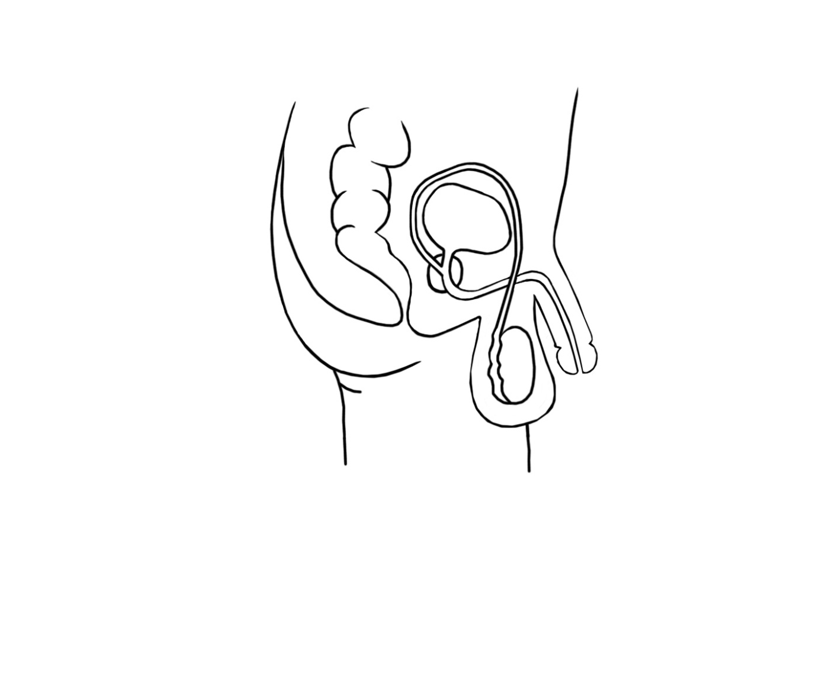
Penis
Urethra
Bladder
Prostate
Rectum
Anus
Vas deferens
Testicle
Scrotum

Male Anatomy
Genitals
Genitals is the word used for the external part of the reproductive system in both males and females. In males, genitals refers to the penis and the scrotum, the skin sac below the penis that contains the testicles.
Penis
The penis is made of two parts: the shaft (the main part) and the glans (the tip). The penis is made of fibrous tissue, nerves, blood vessels and spongy tissue. It delivers sperm and urine through the urethra. When the spongy tissue in the penis fills with blood, it becomes firm.
Scrotum
The scrotum is a sac-like organ made of skin and muscles that holds the testicles. When the testicles become too warm to support making sperm, the scrotum relaxes to move the testes away from the body’s heat. If the testicles become too cold for sperm to develop, the scrotum contracts to move the testes closer to the body’s core heat.
Testicles
The two testicles are the male organs responsible for the production of sperm and testosterone. The testicles are small, oval, glandular organs. Each testicle is found inside its own pouch on each side of the scrotum. The inside of the testicles contain many special cells that divide and form sperm cells through the process of spermatogenesis.
Epididymis
The epididymis is a sperm storage area that wraps around the edge of the testicles. The epididymis is made up of several feet of long, thin tubes that are tightly coiled into a small mass. Sperm produced in the testicles moves into the epididymis to mature before being passed on through the male reproductive organs.
Bladder
The bladder is a muscular sac that stores urine until it is released through the urethra.
Prostate Gland
A small gland that surrounds a portion of the urethra and produces some of the fluid in semen.
Vas Deferens
Vas deferens are thin muscular tubes that transport sperm from the epididymis of each testicle to the urethra.
Urethra
This is a tube that carries semen and urine out of the penis in males.

Starter Anatomy Activity
This can be less in depth for younger children, and more in-depth for older children. All children must be taught the proper names for the genitals.
- Have children separate into small groups.
- Have each group gather around a drawing of an entire body on a large piece of paper
- Have the group label as many parts of body as they can, including eyes, nose, limbs and genitals (penis, scrotum, labia). Encourage them to label genitals even if they are not sure of the correct names. Also ask them to write the function of the body part if they know it, for example – legs for walking
- Stick all diagrams on the board and correct any inaccuracies. It is very important to teach children to correct names for genitals including penis, scrotum, testicles, labia and vagina. This gives them the ability to speak about that area if they should ever need to. (There may be some laughter when mentioning the proper names. To help alleviate giggles, remind them that these are the names that are used by healthcare providers, scientists and farmers, because many mammals have similar body parts with the same names. Part of growing up is to be mature enough to have these kinds of conversations without giggles.)
- Next ask the children to identify which areas of the body are ‘private’. Private areas are the parts which we usually keep covered, and which require our permission for someone else to touch.
Alternative Activity
- Have a large picture of a male and a large picture of a female on the chalkboard.
- Have some cards with the body parts written on them.
- Point to a part of the body and ask the children to volunteer to label it using the cards. This should include the whole body, including arms, legs etc. Ask the children what that body part does, for example, legs for walking, mouth for eating and drinking, ears for hearing.
- Eventually get to the genital area. Young people must be encouraged to use the appropriate names for the ‘private area’ i.e. genitals, penis, scrotum, labia, vagina.
- The children should then identify which areas of the body are ‘private’.

Reproductive Anatomy

For older children aged 12+
- Discuss anatomy of the body. They should then try to identify the ‘reproductive organs’ and their function. The essential inclusions are: genitals (general term for external reproductive parts of males and females including penis, scrotum, labia), vagina, testicles, uterus, fallopian tubes and ovaries. Any further anatomy knowledge is great.
This can be done in the form of a biology lesson. It is important that young people know the correct terms for the organs.

Anatomy Activity – Aimed at ages 10+
This can be done in class or as homework. Print out.
- Check The box that correctly identifies who had each part
- Put the letter from the list that describes each part
Body Part | ONLY BOYS HAVE THIS | ONLY GIRLS HAVE THIS | EVERYONE HAS THIS | DESCRIPTION OF FUNCTION (FROM LIST)
- Urethra
- Penis
- Testicles
- Fallopian tube
- Scrotum
- Vagina
- Anus
- Genitals
- Ovaries
- Bladder

Descriptions and Functions:
a. Carries urine from the bladder to the outside of the body.
b. Two small round organs that produce sperm, which are needed to make a baby.
c. Opening where solid waste (feces or poop) leaves the body.
d. The reproductive system parts on the outside of the body.
e. The organ that stores urine (pee).
f. Store the eggs (ova).
g. Connects the ovaries to the uterus.
h. The passageway from the uterus to outside the body. A baby goes through this tube when it is time to be born.
i. Male external body part that contains the urethra. Urine passes through the urethra in this organ and, in grown males, sperm passes through to leave the body.
j. Pouch of skin that holds the testicles.

Correct Answers – Teacher’s Copy

Body Part | ONLY BOYS HAVE THIS | ONLY GIRLS HAVE THIS | EVERYONE HAS THIS | DESCRIPTION OF FUNCTION (FROM LIST)
- Urethra |  |  | X | A
- Penis | X |  |  | I
- Testicles | X |  |  | B
- Fallopian tube |  | X |  | G
- Scrotum | X |  |  | J
- Vagina |  | X |  | H
- Anus |  |  | X | C
- Genitals |  |  | X | D
- Ovaries |  | X |  | F
- Bladder |  |  | X | E

Puberty

- Discuss puberty. The discussions may be best done in groups separated by gender. However, all topics, including menstrual periods, should be discussed by both gender groups for improved understanding of all aspects of puberty in boys and girls.

The Empower Tanzania puberty video is a good introduction to the topic. A separate Empower Tanzania video explains periods in more depth and can be used for girls as well as boys. This should ideally be taught by a female teacher to enable the girls to feel more comfortable asking questions. Please discuss sanitary product options such as reusable menstrual pads, disposable menstrual pads and tampons. Ideally, it is helpful to show the girls examples of each.

- Discuss the emotions involved in puberty. These should include mood swings, feeling worried, and feeling attraction towards others. Severe facial pimples and oily skin occurring during puberty or menstrual cycles may lead to self-consciousness in boys and girls.

Here it is important to talk openly about these feelings with the emphasis on them being normal and healthy. However, it is important to highlight that feeling attraction towards others does not mean they are ready for a relationship.

Puberty and Periods

Activity – Anonymous Questions – for all ages
- Give each child a small piece of paper.
- Ask them to write a question on that paper. If they have no questions, then they should write ‘no questions’ so no one knows who asked the questions.
- Have the children put them in a hat/box/other container.
- Promise to answer the questions in the next session and ensure this happens. This gives the teacher time to consider the answers to the questions before answering.

Activity – Writing Letters- Age 10+
The aim of this activity to is check the children’s’ understanding of puberty and periods.
Have the children imagine they have received a letter from a younger person asking certain questions. They then have to write a letter back. The letters should be marked by a teacher based on the information given in it, with any inaccuracies corrected. They should also gain praise for being supportive in their letters.

Example of letters are:
Dear Helper,
I am feeling a bit confused and worried. I found a bit of blood in my underwear today. I don’t think I hurt myself, so I’m not sure what it is. Some girls at school said something about a period, but I don’t know what that is. Should I see a doctor? Is there something wrong with me? Please help.
From Catherine

Dear Helper
I have heard from my Mum about something called ‘puberty’ but I’m too embarrassed to ask her what happens. What is puberty and what happens? Does it have to happen?
From Joseph

Teacher Reference Sheet
Puberty

Puberty- This is the period of life during which children’s bodies change to become sexually mature and they become physically capable of reproduction.

Age
Girls usually start puberty between the ages of 8 to 13. Some are earlier, some are later. Boys start a little later, anywhere between 9 and 15. Boys may continue to grow until they are 18 or even later. Once puberty is done, girls and boys will not grow any taller. The changes of puberty usually take about 4 years to occur but it varies a lot. Some people are done with puberty by 17 and others may be over 20 before all the changes have occurred. The thing to remember is that each person is different, and their body will go through puberty at a pace that works for them.

Changes – Both boys and girls
Hormones are released by the testicles in boys and the ovaries in girls. This happens after the brain releases hormones at the start of puberty. The male hormone responsible for the changes is called testosterone, and the female hormone is called estrogen.
During puberty, people will find they sweat more and produce a different type of sweat that can mix with microbes in the air to cause smell.
Oils glands in skin produce more oil. The increased oil on the skin can cause acne, particularly on the face and neck. Acne is the word for when parts of the skin become red, sore and sometimes have a small amount of white drainage.
Hair will grow under the arms, around the genitals and on legs.
Mood swings

Changes – Boys
- Voice deepens after becoming uneven or ‘breaking’
- Muscles become larger
- The penis and testicles grow
- Sperm is produced in the testicles
- Boys have erections and ‘wet dreams’. This is normal
- Hair grows on the genital area and under the arms. Later it grows on the face, back and chest.

Changes – Girls
- Breasts develop. The breasts area may be tender when this is happening
- Hips become wider, and the waist becomes smaller
- Periods start, also called menstruation or menstrual periods
- Hair grows on the legs, genital area and under the arm

Teacher Reference Sheet
Hormones and process of the Menstrual Cycle

Day 1 (Menses) – blood and tissue leaves the vagina
- Level of estrogen very low
- Gonadotropin Releasing Hormone (GnRH) – a hormone that released from the hypothalamus of the brain that stimulates puberty and reproductive function.
- GnRH stimulates the pituitary gland in the brain to release follicle-stimulating hormone (FSH) and luteinizing hormone (LH).
- Follicle-stimulating hormone (FSH) is responsible for making eggs mature in the ovaries. Eggs mature and become surrounded by fluid. This is now known as a follicle.
- Luteinizing hormone (LH) also has a role in maturing the eggs.

Day 7 – end of menses
- The level of estrogen (made in ovaries) has increased significantly. This stops the production of FSH so no more eggs will mature in this cycle.
- Estrogen will continue to increase.

Day 12/13 – ovulation
- When estrogen is significantly high, the level of LH suddenly rises. This causes an egg to be released by the ovary (specifically the follicles).
- The follicles left behind in the ovaries transform to become a structure called the ‘corpus luteum’. They now produce progesterone.
- Progesterone helps thicken the lining on the uterus.

Day 14-28 – fertile phase
- The corpus luteum continue producing progesterone to thicken the lining, which will provide nutrition to the embryo if fertilization occurs. If the embryo implants into the thickened lining of the uterus, the corpus luteum continue to produce progesterone until 10 weeks gestation.
- If no fertilization has occurred, the unfertilized egg passes out of the vagina, the corpus luteum degenerate (dies) and the level of estrogen and progesterone hormones reduces.

Day 1 (menses) – blood and tissue leaves the vagina
- The reduction of hormones leads to the lining of the uterus (endometrium) shedding. This is the start of menses, and is also begins the cycle again.

Sex and Reproduction

There is an Empower Tanzania video called Sexual Health that can help with this session. Children should be provided with this information starting at 10 years old. This is when many children will have an idea about how babies are made and may have heard incorrect myths or rumours. Accurate information answers the child’s questions, and removes the intrigue of mystery. As mentioned before, providing accurate reproductive health information to children and young people reduces the likelihood of unwanted or underage pregnancies, reduces the rates of sexually transmitted diseases, and makes young people more likely to delay initiation of sexual activity until an older age.

Children 10+ years old
- Discuss the biology of sexual intercourse.
This can be done as a biology lesson. It should cover what the act of sexual intercourse is, and how this can make a baby.
A good introduction to this topic is discussing animal reproduction, such as dogs, and how the offspring generally resemble the parents, but are not identical. You can then progress to talk about human reproduction, particularly how it involves a man and a woman, the anatomy involved, and how this makes a baby.

For older children – Aged 12+
- Ask the young people to consider the emotions involved with having sex.
This should be an open discussion, including positive aspects, such as feeling loved, feeling happy etc. It can also include feeling worried or anxious, and feeling confused. Allow them to express themselves and reassure them that all these feelings are normal, but should they have any questions or worries, encourage them to speak to an adult.
Within a Primary school session, an understanding of sex and reproduction is enough without having to discuss STDs and contraception. However, it is recommended that teachers mention that there are some risks of having sex such as ‘infections’ and having a baby when the mother or father is too young.
If any questions are asked, the teacher should answer them fully and honestly. Children may have heard rumours or inaccurate information, so it is important that they receive correct information from the teacher

Teacher Reference
Egg
Sperm
DNA
DNA within nucleus
Organisms have sex cells called gametes. In human beings, the male sex cells are called sperm, and the female sex cells are called ova or eggs. Each sex cell contains 23 chromosomes, the genetic information of life. Human beings have 46 chromosomes in total. This number is achieved by combining the 23 chromosomes from the mother with the 23 chromosomes from the father to complete the 46 chromosomes needed to make a human being. The chromosomes of other animals operate in the same way.
Sexual intercourse refers to the sexual act of an erect penis entering a woman’s vagina. After a while, the penis will release some fluid, called semen through a spurting of this fluid, called ejaculation. The semen includes sperm with the genetic information from the man and other fluid that provides nutrients for the sperm to move.
If this semen is released inside or even near the vagina, it will swim through the cervix, into the uterus and along the fallopian tubes.
If an egg is in the fallopian tube or in the uterus, the sperm may meet the egg. The egg is usually passing through these areas during days 12-16 of a woman’s menstrual cycle. This is called the fertile period because it is when it is most likely that an egg is in the fallopian tube or uterus. However, it is very possible for an egg to be released during other parts of the menstrual cycle and it is possible to become pregnant if sperm are present during other parts of the menstrual cycle.
If the meeting of one single sperm with the egg happens, the sperm joins the egg in a process called fertilization and their two sets of 23 chromosomes join to make 46 chromosomes. Once this happens the joined egg and sperm is referred to as an embryo. The embryo has 46 chromosomes in total and is the beginning of a new human being. This mixing of genetic information from each parent in the form of chromosomes is called sexual reproduction. This is why children generally resemble their parents, but the mixing means they are not identical to either parent.
The embryo continues to move along the fallopian tubes towards the uterus, dividing into more cells along the way. Around 7-14 days after sexual intercourse, the embryo attaches itself to the lining of the uterus. This lining is called the endometrium and the attachment of the embryo to the endometrium is called implantation. Not all embryos are able to implant.
Once implanted, the cells begin to develop differently. The placenta is one of the first parts to develop. The placenta attaches the to the uterine lining and provides continual nutrition to the embryo. The cells now grow at a rapid pace. From around week 8 of the pregnancy, the embryo is called a fetus. Within a fetus, the cells specialise and grow to form the major organs, such as the brain, the liver, and the kidneys. Menses stops for the duration of a pregnancy.

Handout: Important Considerations before Sex
Here are some important questions to answer before making a decision to have sex with a partner:
- How do I feel about sex? When do I think it would be right for me? Under what conditions and with what kind of person?

- How does the other person feel? How do their feelings fit in with my own?

- Is there any chance that I’m pressuring or exploiting the other person? Could they be pressuring or exploiting me?

- What do I expect sex to be like? What if it’s bad and I don’t enjoy it? How would I feel about myself or my partner?

- How would my partner and I feel if others found out about our sexual relationship, specifically those very close to me?

- Do I trust my partner? Completely?

- Am I comfortable being vulnerable in front of my partner, for example being naked with them?

- What if this turns into a strictly sexual relationship and that’s all we ever do? How would I feel then?

- What extra pressures might I (or we) feel once we have sex?

- How will I feel if we break up?

- What will I do to prevent STDs?

- What would I do if I got an STD?
- What will I do to prevent pregnancy?

- How would I/my partner feel if we got pregnant?

- How would my family feel if they found out about my sexual relationship, a pregnancy or an STD? How would I feel about their knowing?

Consent and Sexual Abuse

- Explain what consent is
For use within primary school, a good introduction is discussing how someone knows if a friend wants a hug. Discuss how some people like hugs, and others do not. Also how some people like hugs from certain people, like family, but not from other people.
Explain that if someone gives ‘permission’ for something to happen, then they have given ‘consent’. But it’s not consent if they have been threatened, forced or pressured. It is important to note that “getting permission” from a child is NOT consent because a child is not able to consent to touch in private areas. There is no reason a child should ever be touched in private areas by an adult unless it’s for medical treatment or cleaning purposes.
Always reinforce that young people have the right to say no to anyone touching their bodies at ANY age.
- Silence is not consent.
- “I don’t know” is not consent.
- Consent for a kiss does not mean consent for sexual intercourse.
- A drunk person or a person on drugs cannot give consent.
- “Getting permission” from a child is NOT consent. Anyone under 18-years-old can NOT legally consent to any sexual activity by Tanzanian law.
- Consent is not possible with threat, force or pressure.
At the time when discussing sexual intercourse and reproduction, it is a good time to talk about the legal age when this can happen. Also, sexual intercourse should never happen if someone does not want it to. Here the word ‘rape’ should be introduced, as well as the legal and social consequences for anyone that forces another person to have sex.

Sexual Abuse

- Discuss Sexual Abuse
This topic should be done gently, as it is possible that some students may have been previously abused. It is important to emphasise that sexual abuse can be from ANYONE: someone their own age, someone older, someone in a more powerful position, like a teacher. Be emphatic that sexual abuse is never the victim’s fault.
Sexual abuse may come in many different forms, such as being physically forced to perform sexual acts against a person’s will, being threatened to perform sexual acts, being pressured, or being harassed. For example, someone on the way to school may say crude and sexual things, or make someone watch sexual things. These are all forms of sexual abuse.
- Discuss why sexual abuse may be difficult for the victim to speak about.
Ask the students for their thoughts or ideas about why a sexual abuse victim might have difficulty expressing their feelings or telling about the experience to others. Referring to a victim, students may say ‘they may feel embarrassed’; ‘they may feel like it’s their fault’; ‘they may not understand what is happening’; ‘they may feel they have no choice’ ‘they might feel scared if they or their family have been threatened’; ‘they may be scared people will not believe them’.
After hearing answers from students, discuss these feelings and reassure them that it is always appropriate to tell a trusted person about possible sexual abuse.
Reinforce to the students that no one has a right to touch them in ways that makes them feel uncomfortable, or make them do anything they do not want. No one has the right to make another person feel uncomfortable through sexual comments either.
- Discuss how a person being abused should talk or otherwise communicate with a trusted adult about their experience or concerns, even if it is difficult for them to do so. This is one of the main reasons why they have identified the trusted adults earlier in this training.
Possible ways to communicate with a trusted adult could include: Draw a picture, writing a note, closing your eyes and telling, using a doll or toy to help with the telling, use a doll or toy to do the telling for you so you don’t have to look in their face, using texts or email to tell the trusted adult.

Teacher Reference Sheet- Tanzanian Law
Consent
The age of consent within Tanzania is currently 18 years old. This means that any person under the age of 18 cannot legally consent to any sexual activity.

Statutory Rape
Statutory rape is the term given for the act of a person over 18 to have sex consensually or otherwise, with a person under 18. The person over the age of 18 can be prosecuted. It is also counted as statutory rape if the consent has been obtained by the use of force, threats or intimidation or by putting the fear of death or of hurt while she is in unlawful detention. (Penal Code Cap 16 RE: 2002)
The punishment for having sex with a schoolgirl and getting her pregnant is currently up to 30 years imprisonment.

Marital clauses
However, this becomes more complicated once married: It is lawful for a man to have sexual intercourse with his wife, who may be younger than 18, but must be older than 15. If a wife is over 15 years old, the man does not legally need consent. The Sexual Offence Special Provisions Act (1998) states that:
A male person commits the offence of rape if he has sexual intercourse with a girl or woman under circumstances falling under any of the following descriptions:
- With or without her consent when she is under 18 years of age, unless the woman is his wife who is fifteen or more years of age and is not separated from the man. (Section 5 Rape)
The legal age for a female to be married is 14, with the consent of a court, or 15 with the consent of parents. (Law of Marriages Act 1971). The High Court of Tanzania has stated this will be revised in the near future (July 2016)

Consent to Contraceptive Services
There is currently no legal age to consent to medical treatment, which contraceptive services falls under. Due to this absence of legal directives, there is no minimum age for seeking contraceptive advice, and parental permission is not required. Some clinics may wish for parental consent.

Age for HIV testing
The age of HIV testing in Tanzania is 16. Adolescents aged 16-17 are considered ‘mature minors’ and can consent for themselves, without parental permission. Below the age of 16, parental permission must be sought. However, if the result is positive, health care practitioners are required to report the result to parents if the adolescent is under 18. If over 18, the person has the right to confidentiality of the results.

Abortion
Abortions are illegal within Tanzania unless to save the mother’s life. (Penal code cap 16:2002)
Southern African AIDS Trust (2016) . Age of Consent: Legal Review. Tanzania Country Report. Online. Available childrenandaids.org Accessed 22/09/17

Contraception and STDs
When discussing contraception and STDs it is important for the teacher to allow open discussion, even if they do not personally agree with the discussion. While abstinence is the only way of being 100% free from risks of pregnancy or STDs, some young people may engage in sexual relationships. In addition to this, after young people leave school, there are very few opportunities for them to be taught about contraception or family planning later in life, whether married or single. For this reason, contraception must be discussed as well as where to seek advice regarding contraception. It should be emphasised that contraception and protection is the responsibility of BOTH partners. Also, that contraception is available to anyone at any age from healthcare facilities and at no cost.
Unprotected sex definition: Sex without methods to prevent pregnancy or the spread of sexually transmitted infections, such as HIV/AIDS.

- Discuss the risks of unprotected sex
Have the young people name as many ‘risks’ as they know such as HIV, pregnancy, syphilis. Then discuss the risk and implications of pregnancy, as well as the most common five STDs (see Teacher Reference Sheet)
The risks of unprotected sex are pregnancy and many different STDs, including HIV. Discuss how having a pregnancy now means that a girl cannot continue her education and how this will impact her entire life. She may have many other financial and emotional tolls from an early pregnancy that could be completely avoided by using contraception and condoms.
- Discuss how to avoid these risks
Have the young people name as many ways of avoiding these risks as possible. These could include abstinence, condoms, pills, etc. At this point, young people may suggest things that are false, such as ‘only having sex while standing up’; ‘pulling the penis out before ejaculation’ or other incorrect statements. Allow these suggestions to be discussed, but ensure the young people know that these are FALSE. Always correct any inaccuracies stated by students.
It is very important here that non-abstinence ways are discussed alongside abstinence. Examples should include contraception, such as the contraceptive pill, injection, implant, IUDs, IUSs and condoms. It is important to emphasise that the only way to protect against STDs is by using condoms or abstaining. Ideally, the teacher should have a condom available to show the pupils.

Within this discussion, the teacher should make pupils aware that they must seek medical help if they think they may have been exposed to STDs, and that some STDs can be treated easily. Ensure they know this can be done in private and no one has to know.

Teacher Reference Sheet

Contraception
Young people should be made aware of the vast number of options available for use as contraception. It is important to highlight that only condoms prevent STDs. Below is some basic information about each type. Additional information can be found from reliable sources online or from visiting clinics.

Combined pill
- 99% effective when taken correctly: the pill prevents ovaries releasing an egg each month; thickens cervical mucus lining making it harder for sperm to reach egg; thins the lining of uterus making it less likely a fertilised egg would attach and grow.
- Take one pill for 21 days then have a 7 day break. During the break, a woman will have a period-like bleed. Start again after 7 days
- Pill needs to be taken regularly. Risk of pregnancy otherwise
- Can help with heavy or painful periods
- Risks: No protection against STDs; very low risk of blood clots; mood swings; breast tenderness, headaches.

Progesterone-Only Pill
- 99% effective when taken correctly: thickens the cervical mucus lining so it is more difficult for sperm to reach egg. Some types also prevent ovulation.
- Take one pill every day. No breaks
- Needs to be taken within the same 3 hour period each day. Risk of pregnancy otherwise
- Suitable for women with high blood pressure or a history of blood clots
- Can help with heavy or painful periods. Periods may stop altogether
- Risks: No protection against STDs; spots on skin; breast tenderness; irregular or more frequent periods

Contraceptive Implant
- 99% effective: uses progesterone to stop ovulation; thickens cervical mucus lining making it harder for sperm to reach an egg; makes uterus lining thinner so less likely a fertilised egg would attach and grow.
- Small device put in under the skin on the inside upper arm
- Stays in place and effective for 3 years
- Can be removed at any time
- Can help with heavy or painful periods. Periods often stop altogether
- Risks: No protection from STDs; when first put in there may be some bruising, tenderness or swelling; After settled, periods may become irregular or heavier.

Contraceptive Injection
- 99% effective: uses progesterone to stop ovulation; thickens cervical mucus lining making it harder for sperm to reach an egg; makes uterus lining thinner so less likely a fertilised egg would attach and grow
- Injection into muscle in buttocks, abdomen or thigh every 8-13 weeks (depending on the type of injection used – discuss with doctor) providing continuous protection against pregnancy
- Can help with heavy or painful periods
- Risks: No protection from STDs; weight gain; headaches; mood swings; breast tenderness; irregular bleeding; heavy bleeding; takes one year after stopping the injection for fertility to return to normal

IUD (Intrauterine Device)
- Over 99% effective: releases copper in the uterus which changes the fluids in the uterus and fallopian tubes to prevent sperm from surviving. Can also stop a fertilised egg from attaching to the uterus and growing.
- Small ‘T’ shaped device made of copper and plastic inserted into uterus by nurse or doctor
- Lasts for 5-10 years (depending of type inserted)
- Can be removed any time
- Risks: No Protection from STDs; changes to periods (heavier, longer or more painful common in first 6 months); small risk of infection within 20 days of insertion; uncomfortable to be fitted; cramping for a few weeks after insertion

IUS (Intrauterine System)
- Over 99% effective: Releases progesterone which can stop ovulation; thickens cervical mucus lining making it harder for sperm to reach an egg; makes uterus lining thinner so less likely a fertilised egg would attach and grow
- Small ‘T’ shaped device made of plastic inserted into uterus by nurse or doctor
- Lasts for 3-5 years (depending on type inserted)
- Can be removed any time
- Can help with heavy or painful periods. Often stops periods altogether
- Risks: no protection from STDs; small risk of infection within 20 days of insertion; uncomfortable to be fitted; cramping for a few weeks after insertion; mood swings; skin problems; breast tenderness

Condoms (Male)
- 98% effective when used correctly: stops sperm reaching an egg by a physical barrier.
- Latex (thin rubber) or similar barrier placed onto erect penis before any sexual contact
- Used once each, removed while penis is still erect after ejaculation, then disposed of in a bin
- Protects against most STDs
- No use of hormones
- No need for a medical appointment
- Risks: Condoms can slip, or tear especially if not put on correctly. This could lead to pregnancy; some people may be allergic to latex but can use other types of condoms.

Condoms (Female)
- 95% effective: stops sperm reaching an egg by a physical barrier
- Plastic or similar barrier inserted into the vagina before any sexual contact
- Used only once, removed after ejaculation, then disposed of in a bin
- Do not use a female condom and male condom together
- Protects against most STDs
- No use of hormones
- Risks: condom can be pushed too far into vagina (easily retrieved by person); Penis can enter vagina outside of female condom by mistake which may result in pregnancy; if not removed properly, semen can spill out and result in pregnancy.

Teacher Reference Sheet
Sexually Transmitted Diseases (STDs)
The exact prevalence rates for Sexually Transmitted Diseases (STDs) is difficult to find due to difficultly in collecting data. But data collected from various sources all show that Sub-Saharan Africa, which includes Tanzania, has the highest rate of STDs anywhere in the world (WHO 2008; Kenyon, Buyze and Colebunders, 2014).
The top 5 most common STDs in the area are (in no order):
Gonorrhea
Syphilis
Chlamydia
Trichomonas Vaginalis
HIV/AIDS
For each 1000 people, these are the estimated number of people suffering from each STD. The numbers are taken from large data collection research projects (WHO, 2008; WHO Kenyon, Buyze, Colbunders, 2014)
Type of STD | Number of people affected/ 1000 people
Gonorrhea | 49.7 – 63.3
Syphilis | 8.5 – 14.2
Chlamydia | 20.9 – 59.1
Trichomonas Vaginalis | 119.4 – 164.8

HIV/AIDs
HIV prevalence rates have shown that 5.6% of the population in Tanzania are HIV-Positive (Global Health Observatory, 2010). In 2012 the Global Health Observatory found that of every 100, 000 people 167 people will die each year of HIV/AIDS in Tanzania.
It is clear to see that sexually transmitted diseases affect many people in the area. Young people should be made aware of the risks.
Important points to emphasise:
- Anyone can get a STD at any time of their life. INCLUDING their first time having sex.
- There are often no symptoms, so the only way to be sure a person does not have an infection is to be tested
- Young people do not have to have parental permission to seek medical advice or testing
- Some people may have had the infection/virus from birth (HIV in particular) so even if the partner has not had sex before, they may still be infected.

Teacher Reference Sheet: STDs

Type of STD | Symptoms | Curable? | Treatment | Risks if left untreated
Gonorrhea | Often no symptoms.  -burning when urinating  -white, yellow or green discharge from penis  -painful swollen testicles  -Increased vaginal discharge  -vaginal bleeding between periods  -soreness  - anal itching | YES | Course of medication: antibiotics | -Scar tissue blocks fallopian tubes  - Ectopic pregnancy (pregnancy outside of uterus)  - Infertility  - Pelvic Inflammatory Disease (PID)
Syphilis | -sores around or inside the genitals (firm, round painless)  -skin rash  -fever | YES | Course of medication: antibiotics | -Arthritis  -Brain damage  -Blindness  -Severe heart problems  -Impotence  -Death
Chlamydia | Often no symptoms  -abnormal vaginal discharge  -burning sensation when urinating  -discharge from the penis  -pain or swelling in testicles | YES | Course of medication: antibiotics | -Pelvic Inflammatory Disease  -Infertility  -Ectopic pregnancy
Trichomonas Vaginalis | Often no symptoms  -itching or irritation inside penis  -burning or discomfort on urination  -discharge from the penis  -change in vaginal discharge  -itching, burning or soreness of the genitals  -unpleasant to have sex | YES | Course of Medication: antibiotics | -Increased risk of getting other infections, especially HIV  -Risk of heaving unhealthy babies (low birth weight, health or developmental problems)
HIV/AIDS | -flu-like illnesses (fever, headache, joint and muscle pain, rash, sore throat)  -diarrhoea  -weight loss  -white lumps on or around mouth  -skin rashes or bumps | NO  (Seek Emergency Medical Assistance within one hour of possible infection, for possible prevention) | Treatment with medication can help with symptoms and control the virus: anti-retrovirals. | -Persistent illnesses from a damaged immune system  -Death

Activity: Putting on a Condom (Aimed at 14-16 year olds)
The following is the correct order for putting on a condom. Write out the stages on the board out of order and have the class put them in the correct order in groups, writing them on a piece of paper. Then go group-to-group asking each to give one stage at a time, until all 11 stages are in order. It is especially beneficial to have a several condoms to show the pupils.
- Check expiration date on condom
- Have erection
- Take condom from wrapper
- Put condom right side up on head of penis
- Pinch the tip
- Roll condom down penis
NOTE: If condom doesn’t roll down the penis, it is probably upside down. A new condom should be used because the old condom probably has sperm on it.
- Begin intercourse
- Ejaculation
- Withdraw penis from partner, holding condom on at the base
- Remove condom from penis
- Throw condom away in trash

This program has been written by Empower Tanzania Incorporated. Same. Tanzania.
Email: information@empowertz.org
Content provided by Jessica Haworth (MNurSci; RN Child) and Jeffrey Carithers, MD, FACS
2018

